Project Submission

Web Application User Interface

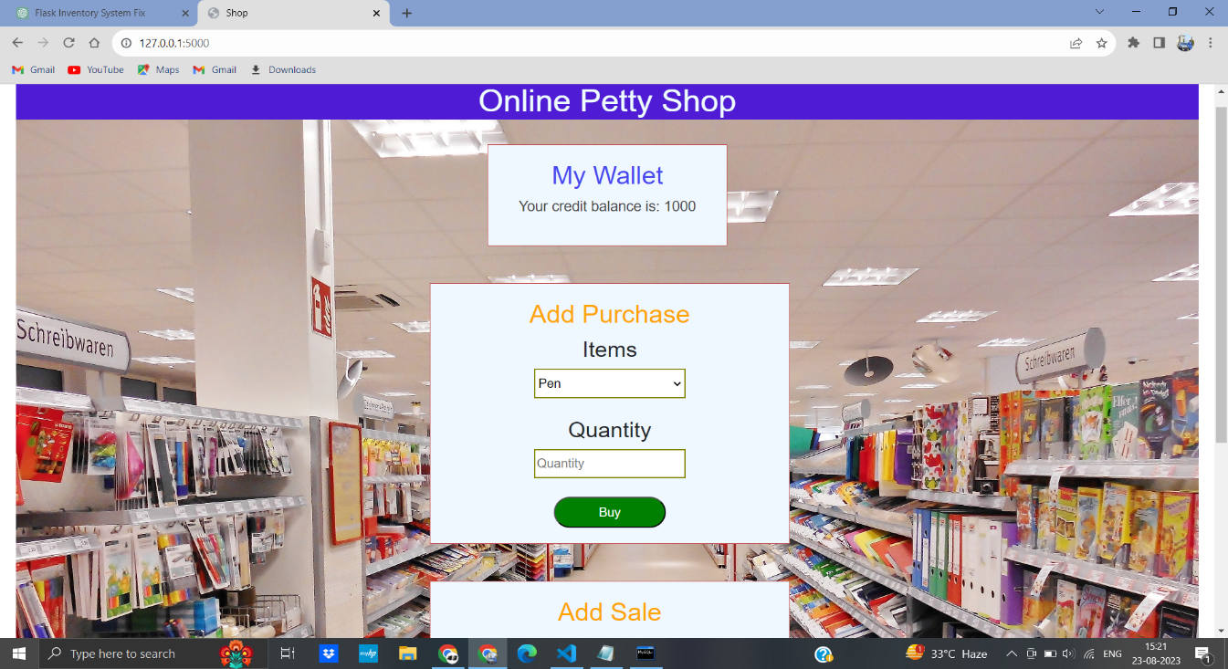

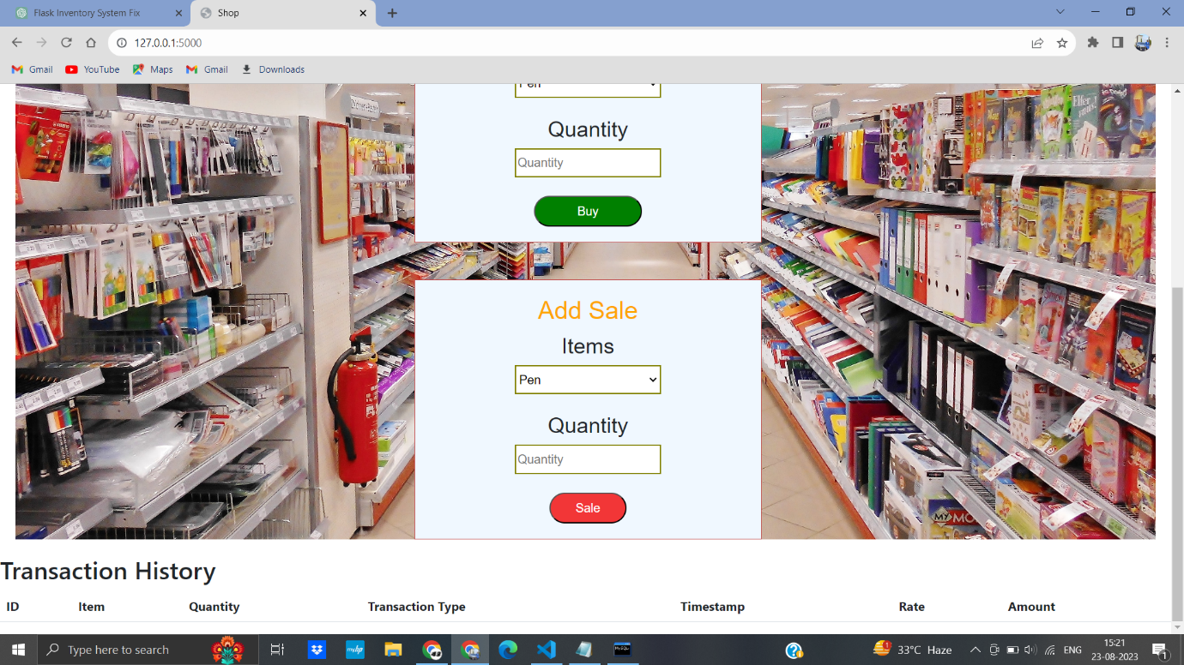

MyWallet

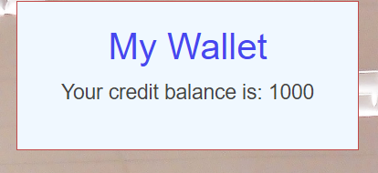

Initial Wallet 1000 fixed the amount in database

Purchase Item

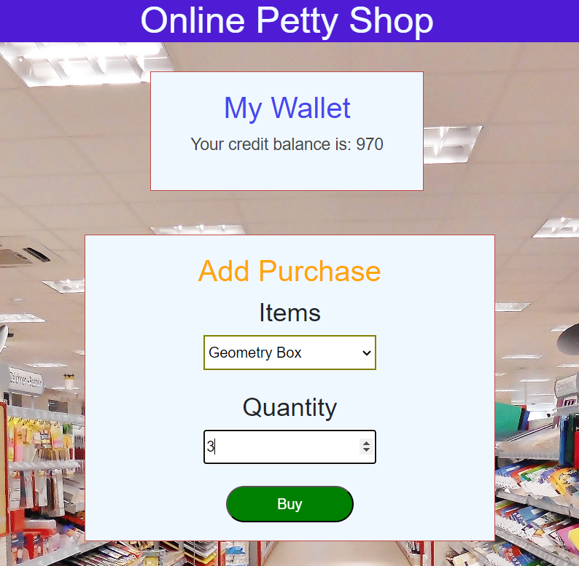

Geomentry Box rate Rs. 10

Total 3 Quantity

Total amount Rs.30

And same time update my wallet 1000 – 30 = 970

Store database Buy Transcation History

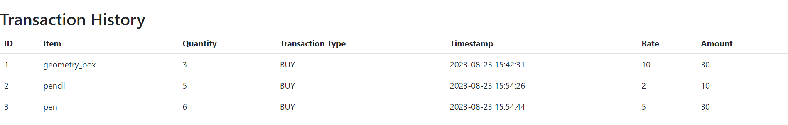

Sales Item

Sells price = cost price \* 2

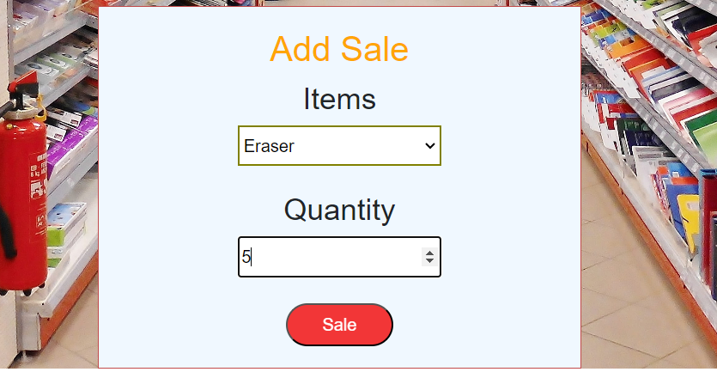

Erase price 2 and Quantity 5

Total Amount 2\*5= Rs.10

Update MyWallet

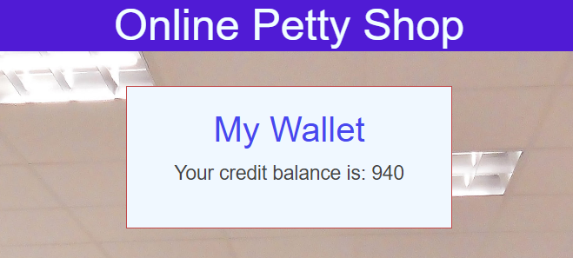

Store database Sales Transcation History



Store the data MySql Working Process

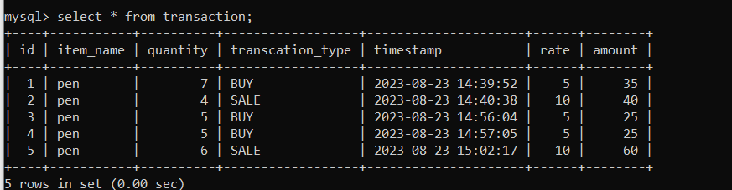

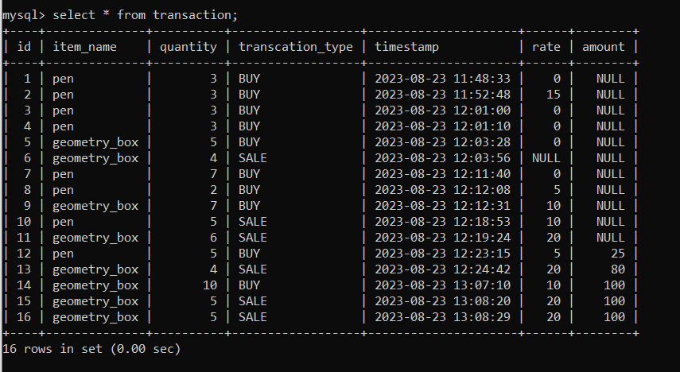

Transcation History

